Abstract
Background: Emergency Department (ED) crowding is a critical public health challenge. Prolonged boarding (≥8 hours) affects over 20% of visits. Hospital admission and prolonged hospitalization (>7 days) consume disproportionate resources. Clinicians currently rely on triage scales like the Emergency Severity Index (ESI), which have limited predictive accuracy. Machine learning (ML) using triage-only data could support these decisions, but evidence on model accuracy remains limited.
Methods: Using the MC-MED dataset (118,385 adult ED visits), we evaluated four ML models (XGBoost, LightGBM, Random Forest, TabNet) on three binary classification tasks using 29 admission-available variables: (1) predicting prolonged ED length of stay (ED-LOS ≥8 hours vs. <8 hours), (2) predicting hospital admission (admit vs. discharge), and (3) predicting prolonged hospital length of stay (hospital LOS >7 days vs. ≤7 days) among admitted patients. All 29 features were available within 90 minutes of arrival. Area under the receiver operating characteristic curve (AUC-ROC) was the primary performance metric. SHAP (SHapley Additive exPlanations) analysis identified the most important features for each prediction task.
Results: For ED-LOS ≥8 hours, XGBoost achieved an AUC-ROC of 0.660 (95% CI: 0.652-0.668). For hospital admission, XGBoost achieved an AUC-ROC of 0.817 (95% confidence interval [CI]: 0.810-0.824), an improvement over the ESI baseline of 0.678. For hospital LOS >7 days among admitted patients, Random Forest achieved an AUC-ROC of 0.671 (95% CI: 0.662-0.680). SHAP analysis identified consistent top predictors across tasks: triage acuity, emergency medical services (EMS) arrival, age, disease condition count, and the Charlson Comorbidity Index.
Conclusion: ML using only triage-available data accurately predicts three critical ED binary treatment outcomes. SHAP analysis provides interpretable feature importance to support clinical decision-making.
Keywords: machine learning, emergency department, hospital admission, length of stay, Shapley Additive Explanations

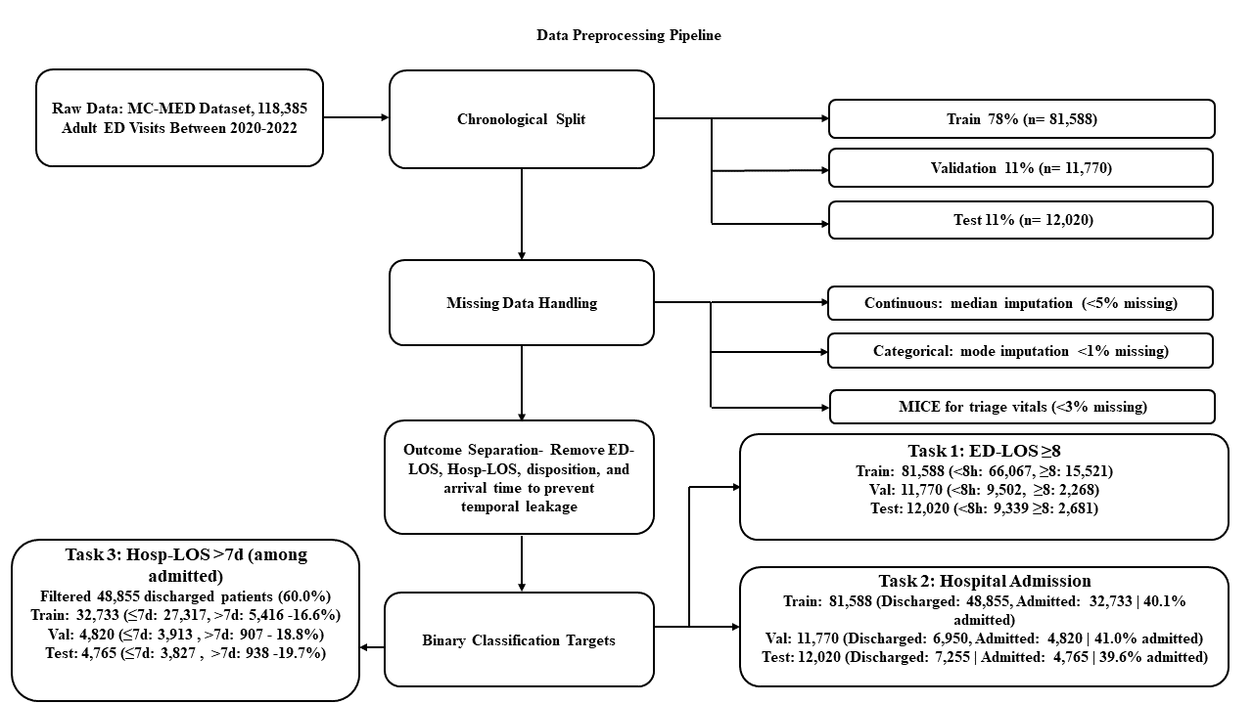
Diagram 1

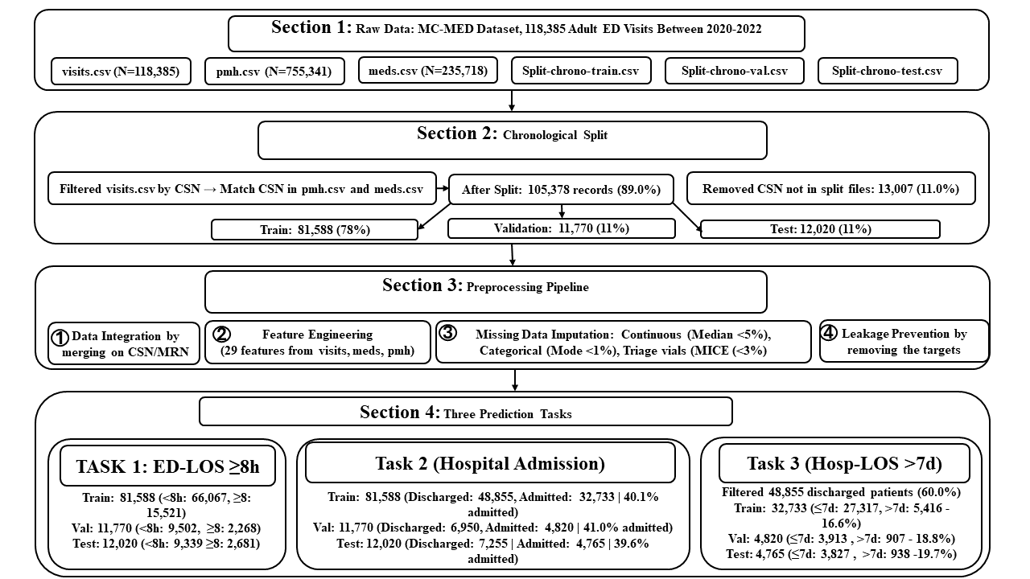
Diagram 2

